Code and Screenshots

PA1_CPU_First

#include <stdio.h>

#include <pthread.h>

#include <time.h>

#include <sys/time.h>

#include <math.h>

float threadFunc_int(long int noItr)

{

int i,val1=1,val2=2,val3=4;

struct timeval start_time;

struct timeval end_time;

gettimeofday(&start_time,NULL);

for(i=0;i<noItr;i++)

{

val1=val2*val3;

val3=val1+val2;

val2=val3-val1;

val1=val2/val3;

}

gettimeofday(&end_time,NULL);

printf("%d %d",end_time.tv_sec,start_time.tv_sec);

float timeTaken=(float)(end_time.tv_sec-start_time.tv_sec);

return timeTaken;

}

float threadFunc_float(long int noItr)

{

int i;

float val1=1.2,val2=2.4,val3=4.6;

struct timeval start_time;

struct timeval end_time;

gettimeofday(&start_time,NULL);

for(i=0;i<noItr;i++)

{

val1=val2*val3;

val3=val1+val2;

val2=val3-val1;

val1=val2/val3;

}

gettimeofday(&end_time,NULL);

float timeTaken=(float)(end_time.tv_sec-start_time.tv_sec);

return timeTaken;

}

int main(void)

{

int i=0;

int noThreads;

struct timeval begin_time;

struct timeval last_time;

int op;

float timeTaken=0;

float avgTime=0.0;

printf("Enter Operation to Perform 1 int 2 float");

fflush(stdout);

scanf("%d",&op);

printf("Enter threads");

fflush(stdout);

scanf("%d",&noThreads);

pthread_t pth[noThreads];

for(i=0;i<noThreads;i++)

{

if(op==1)

pthread_create(&pth[i],NULL,threadFunc_int,100000000);

else

pthread_create(&pth[i],NULL,threadFunc_float,100000000);

}

for(i=0;i<noThreads;i++)

{

pthread_join(pth[i],&timeTaken);

avgTime=avgTime+timeTaken;

}

float ops=(float)(100000000*4*noThreads)/avgTime;

if(op==1)

{

printf(" Iops in Hertz is %f",(double)ops);

printf(" Iops in Giga Hertz is %f",ops/1000000000);

}

else

{

printf(" Flops in Hertz is %lf",ops);

printf(" Flops in Giga Hertz is %f",ops/1000000000);

}

return 0;

}

PA1_CPU_Second.c

#include <stdio.h>

#include <pthread.h>

#include <time.h>

#include <sys/time.h>

#include <fcntl.h>

#include <sys/stat.h>

pthread_mutex_t lock;

int threadFunc_int(int s)

{

int i=0,a=1,b=2,c=4;

struct timeval t1;

struct timeval t2;

gettimeofday(&t1,NULL);

for(i=0;i<s;i++)

{

a=b*c;

c=a+b;

b=c-a;

a=(int)b/c;

gettimeofday(&t2,NULL);

if(t2.tv_sec-t1.tv_sec==1)

{

//printf("i is %d",i);

return i;

}

}

}

int threadFunc_float(int s)

{

int i;

float a=1.2,b=2.3,c=4.5;

struct timeval t1;

struct timeval t2;

int timer=0;

while(timer==0)

{

gettimeofday(&t1,NULL);

for(i=0;i<s;i++)

{

a=b*i;

c=a+b;

b=c-a;

a=(float)b/c;

gettimeofday(&t2,NULL);

if(t2.tv_sec-t1.tv_sec==1)

{

timer=1;

//printf("%d",i);

return i;

}

}

}

}

int main(void)

{

int i=0,j=0;

int noThreads;

int op;

/* if (pthread_mutex_init(&lock, NULL) != 0)

{

printf("\n mutex init failed\n");

return 1;

}

*/

printf("Enter Operation 1 int 2 float");

fflush(stdout);

scanf("%d",&op);

printf("Enter threads");

fflush(stdout);

scanf("%d",&noThreads);

pthread_t pth[noThreads];

char *fileName="values.txt";

int fileDesc = open(fileName,O_CREAT|O_RDWR,S_IRWXU);

for(j=0;j<600;j++)

{

int f=0;

float avg=0;

for(i=0;i<noThreads;i++)

{

if(op==1)

{

pthread_create(&pth[i],NULL,threadFunc_int,100000000);

}

else

{

pthread_create(&pth[i],NULL,threadFunc_float,100000000);

}

}

for(i=0;i<noThreads;i++)

{

pthread_join(pth[i],&f);

avg=(float)avg+(f*4);

//printf("avg is %f",avg);

}

//printf("\n avg is %d",(int)avg/noThreads);

float iops=(float)(avg/noThreads);

printf("\n flops is %f ",iops);

printf("\n flops in Giga Hertz is %f",iops/1000000000);

char *c = (char *)malloc(sizeof(char)*10);

sprintf (c,"%f",iops/1000000000);

strcat(c,"\r\n");

write(fileDesc,c,strlen(c));

}

return 0;

}

Pa1_Memory.c

**#include <stdio.h>**

**#include <pthread.h>**

**#include <time.h>**

**#include <sys/time.h>**

**#include <fcntl.h>**

**#include <sys/stat.h>**

**#include <malloc.h>**

**pthread_mutex_t lock;**

**struct timeval start_time,end_time;**

**float seq_thread_func(long int size)**

**{**

**// allocate a memory of blocksize 20 mb ,**

**//read blocks of data using sequentital access from one memory area to other using memcpy**

**//and return the time taken for read and write**

**int k=0;**

**pthread_mutex_lock(&lock);**

**long int blockSize=(long int)(20*1000000)/size;**

**char *mem1;**

**char *mem2;**

**mem1=malloc(blockSize*size);**

**mem2=malloc(blockSize*size);**

**strncat(mem2,"hello",blockSize*size);**

**gettimeofday(&start_time,NULL);**

**for(k=0;k<(long int)(blockSize);k++)**

**{**

**memcpy(mem1+k,mem2+k,size);**

**// copy required bytes from one memory to other sequentially**

**}**

**gettimeofday(&end_time,NULL);**

**double data1=(double)start_time.tv_sec+((double)start_time.tv_usec/1000000);**

**double data2=(double)end_time.tv_sec+((double)end_time.tv_usec/1000000);**

**float dataTime=data2-data1;//calculate the time taken for read and write in sec**

**free(mem1);**

**free(mem2);**

**printf("%f",dataTime);**

**pthread_mutex_unlock(&lock);**

**return dataTime;**

**}**

**float random_thread_func(long int size)**

**{**

**// allocate a memory of blocksize 20 mb ,**

**//read blocks of data using random access from one memory area to other using memcpy**

**//and return the time taken for read and write**

**int random_pos=0,k;**

**pthread_mutex_lock(&lock);**

**long int blockSize=(1000000*20)/size;**

**char *mem1;**

**char *mem2;**

**mem1=malloc(blockSize*size);//allocate memory**

**mem2=malloc(blockSize*size);//allocate memory**

**strncat(mem2,"hello",blockSize*size);**

**gettimeofday(&start_time,NULL);**

**for(k=0;k<(long int)blockSize;k++)**

**{**

**random_pos = rand()%(blockSize);**

**memcpy(mem1+random_pos,mem2+random_pos,size);**

**// copy required bytes from one memory to other in random_pos position**

**}**

**gettimeofday(&end_time,NULL);**

**double data1=(double)start_time.tv_sec+((double)start_time.tv_usec/1000000);**

**double data2=(double)end_time.tv_sec+((double)end_time.tv_usec/1000000);**

**float dataTime=data2-data1;//calculate the time taken for read and write in sec**

**free(mem1);**

**free(mem2);**

**printf("%f",dataTime);**

**pthread_mutex_unlock(&lock);**

**return dataTime;**

**}**

**void main()**

**{**

**float throughput,latency;**

**int access;**

**int nothreads;**

**int operation;**

**long int size;**

**int i;**

**float timeTaken=0,data=0;**

**printf("\n Block size:(Select 1 for 1B=1,2 for 1KB=1024,3 for 1MB=1048576):");**

**fflush(stdout);**

**scanf("%d",&size);**

**printf("Access Method : 1-Sequential 2-Random");**

**fflush(stdout);**

**scanf("%d",&access);**

**printf("Enter number of threads 1,2,4 :");**

**fflush(stdout);**

**scanf("%d",&nothreads);**

**pthread_t pth[nothreads];**

**if(size==2)**

**{**

**// if 2 is selected assign 1024 bytes to read and write in memory**

**size=(long int)1024;**

**}**

**if(size==3)**

**{**

**// if 3 is selected assign 1024*2014 bytes to read and write in memory**

**size=(long int)(1024*1024);**

**}**

**if (pthread_mutex_init(&lock, NULL) != 0)**

**{**

**printf("\n mutex init failed\n");**

**return 1;**

**}**

**// create given no of threads and perform operations (read/write)**

**for(i=0;i<nothreads;i++)**

**{**

**if(access==1)**

**//this block is for doing memcopy sequentially**

**pthread_create(&pth[i],NULL,seq_thread_func,(long int)size);**

**else**

**//this block is for doing memcopy to random memory**

**pthread_create(&pth[i],NULL,random_thread_func,(long int)size);**

**}**

**// joining the thread with other thread**

**for(i=0;i<nothreads;i++)**

**{**

**pthread_join(pth[i],&data);**

**timeTaken=timeTaken+data; // add the time taken for all threads**

**}**

**printf("%f",timeTaken);**

**timeTaken=timeTaken/nothreads;**

**latency=(float)(timeTaken*size*1000)/(2*1000000*20);**

**printf("Latency in milliseconds : %f \n",latency);**

**throughput = (float)(1000000*20*2)/(timeTaken);//(no of loops*size*2/time taken)**

**printf("Throughput in MB/sec : %f\n",(throughput)/(1024*1024));**

**int filesc;**

**char *fs="values.txt";**

**filesc = open(fs,O_CREAT|O_RDWR,S_IRWXU);**

**char *c = (char *)malloc(sizeof(char)*10000);**

**char *s = (char *)malloc(sizeof(char)*10);**

**s[0]='\0';**

**c[0] = '\0';**

**strcat(c,"\r\n");**

**strcat(c,"size");**

**strcat(c," ");**

**strcat(c,"threads");**

**strcat(c," ");**

**strcat(c,"access");**

**strcat(c," ");**

**strcat(c,"throughput");**

**strcat(c," ");**

**strcat(c,"latency");**

**strcat(c,"\r\n");**

**sprintf (s,"%d",(int)size);**

**strcat(c,s);**

**strcat(c," ");**

**s[0]='\0';**

**sprintf (s,"%d",(int)nothreads);**

**strcat(c,s);**

**strcat(c," ");**

**sprintf(s,"%d",(int)access);**

**strcat(c,s);**

**strcat(c," ");**

**sprintf(s,"%f",(float)throughput/(1024*1024));**

**strcat(c,s);**

**strcat(c," ");**

**s[0]='\0';**

**sprintf(s,"%f",(float)latency);**

**strcat(c,s);**

**strcat(c,"\r\n");**

**printf("\n c is \n %s",c);**

**write(filesc,c,strlen(c));**

**free(c);**

**free(s);**

**}**

Pa1_Disk.c#include <stdio.h>

#include <pthread.h>

#include <time.h>

#include <sys/time.h>

#include <fcntl.h>

#include <sys/stat.h>

int fileDesc ;

pthread_mutex_t lock;

struct timeval start_time,end_time;

float write_thread_seq(long int size)

{

// open the file , write blocks of data using sequential access and return the time taken for write

pthread_mutex_lock(&lock);

long int blockSize=(long int)((1000000*20)/size);

char *fileName="trial.txt";

fileDesc = open(fileName,O_RDWR,S_IRWXU);

int itr;

char *writeData;

writeData=(char *)malloc(size);

gettimeofday(&start_time,NULL);

for(itr=0;itr<blockSize;itr++)

{

int currentPageSize =write(fileDesc,writeData,size);//write sequentially from starting position of file

}

gettimeofday(&end_time,NULL);

double data1=(double)start_time.tv_sec+((double)start_time.tv_usec/1000000);

double data2=(double)end_time.tv_sec+((double)end_time.tv_usec/1000000);

float dataTime=(double)data2-data1;//calculate the time taken for write in sec

pthread_mutex_unlock(&lock);

free(writeData);

return dataTime;

}

float read_thread_seq(long int size)

{

// open the file , read blocks of data using sequential access and return the time taken for read

long int blockSize=(long int)(1000000*20)/size;

pthread_mutex_lock(&lock);

char *fileName="trial.txt";

fileDesc = open(fileName,O_RDWR,S_IRWXU);

int itr;

char *readData;

readData=(char *)malloc(size);

gettimeofday(&start_time,NULL);

for(itr=0;itr<blockSize;itr++)

{

int currentPageSize =read(fileDesc,readData,size);//read sequentially from starting position of file

}

gettimeofday(&end_time,NULL);

double data1=(double)start_time.tv_sec+((double)start_time.tv_usec/1000000);

double data2=(double)end_time.tv_sec+((double)end_time.tv_usec/1000000);

float dataTime=data2-data1;//calculate the time taken for read in sec

pthread_mutex_unlock(&lock);

free(readData);

return dataTime;

}

float write_thread_random(long int size)

{

// open the file , write blocks of data using random access and return the time taken for write

int itr;

off_t random_pos;

long int blockSize=(long int)(1000000*20)/size;

char *fileName="trial.txt";

char *writeData;

fileDesc = open(fileName,O_RDWR,S_IRWXU);

pthread_mutex_lock(&lock);

writeData=(char *)malloc(size);

gettimeofday(&start_time,NULL);

for(itr=0;itr<blockSize;itr++)

{

random_pos = rand()%(int)blockSize;//assign random block to write

int currentPageSize =pwrite(fileDesc,writeData,size,random_pos);// writes from random block position

}

gettimeofday(&end_time,NULL);

double data1=(double)start_time.tv_sec+((double)start_time.tv_usec/1000000);

double data2=(double)end_time.tv_sec+((double)end_time.tv_usec/1000000);

float dataTime=data2-data1;//calculate the time taken for write in sec

free(writeData);

pthread_mutex_unlock(&lock);

return dataTime;

}

float read_thread_random(long int size)

{

// open the file , read blocks of data using random access and return the time taken for read

int itr;

off_t random_pos;

long int blockSize=(long int)(1000000*20)/size;

char *fileName="trial.txt";

char *readData;

fileDesc = open(fileName,O_RDWR,S_IRWXU);

pthread_mutex_lock(&lock);

readData=(char *)malloc(size);

gettimeofday(&start_time,NULL);

for(itr=0;itr<blockSize;itr++)

{

random_pos = rand()%(int)blockSize;//assign random block to read

int currentPageSize =pread(fileDesc,readData,size,random_pos);// read from random block position

}

gettimeofday(&end_time,NULL);

double data1=(double)start_time.tv_sec+((double)start_time.tv_usec/1000000);

double data2=(double)end_time.tv_sec+((double)end_time.tv_usec/1000000);

float dataTime=data2-data1; //calculate the time taken for read in sec

free(readData);

pthread_mutex_unlock(&lock);

return dataTime;

}

void main()

{

float throughput,latency;

int access;

int nothreads;

int operation;

long int size;

int i;

float timeTaken=0,dataTime;

printf("Enter Operation to perform 1-Read 2-Write");

fflush(stdout);

scanf("%d",&operation);

printf("\n Block size:(Select 1 for 1B=1,2 for 1KB=1024,3 for 1MB=1048576):");

fflush(stdout);

scanf("%d",&size);

printf("Access Method : 1-Sequential 2-Random");

fflush(stdout);

scanf("%d",&access);

printf("Enter number of threads 1,2,4 :");

fflush(stdout);

scanf("%d",&nothreads);

pthread_t pth[nothreads];

if(size==2)

{

// if 2 is selected assign 1024 bytes to read or write from disk

size=(long int)(1024);

}

if(size==3)

{ // if 3 is selected assign 1024*2014 bytes to read or write from disk

size=(long int)(1024*1024);

}

if (pthread_mutex_init(&lock, NULL) != 0)

{

printf("\n mutex init failed\n");

return 1;

}

char *fileName="trial.txt";

char *f="hs";

fileDesc = open(fileName,O_CREAT|O_RDWR,S_IRWXU);

for(i=0;i<=(1024*1024*20);i++)

{

int currentPageSize =write(fileDesc,f,2);

}

// create given no of threads and perform operations (read/write)

for(i=0;i<nothreads;i++)

{

if(access==1 && operation==1)

{

//this block is for read operation sequential access

pthread_create(&pth[i],NULL,read_thread_seq,(long int)size);

//creates a thread and calls read_thread function

}

if(access==2 && operation==1 )

{ //this block is for read operation random access

pthread_create(&pth[i],NULL,read_thread_random,(long int)size);

//creates a thread and calls read_thread_random function

}

if(access==1 && operation==2)

{ //this block is for write operation using sequential access

pthread_create(&pth[i],NULL,write_thread_seq,(long int)size);

//creates a thread and calls write_thread_seq function

}

if(access==2 && operation==2)

{ //this block is for write operation using random access

pthread_create(&pth[i],NULL,write_thread_random,(long int)size);

//creates a thread and calls write_thread_random function

}

}

// joining the thread with other thread

for(i=0;i<nothreads;i++)

{

pthread_join(pth[i],&dataTime);

timeTaken=(float)timeTaken+dataTime; // add the time taken for all threads

}

timeTaken=(timeTaken)/nothreads;

throughput=(float)(1000000*20)/(timeTaken); //(no of loops*size*2/time taken)

latency=(float)(timeTaken*1000*size)/(1000000*20);

if(access==1 && operation==1)

{

printf("Throughput for sequential access read is %f ",(float)(throughput)/(1024*1024));

printf("Latency for sequential access read is %f",latency);

}

if(access==2 && operation==1)

{

printf("Throughput for random access read is %f",(float)(throughput)/(1024*1024));

printf("Latency for random access read is %f",latency);

} if(access==1 && operation==2)

{

printf("Throughput for sequential access write is %f",throughput/(1024*1024));

printf("Latency for sequential access write is %f",latency);

}

if(access==2 && operation==2)

{

printf("Throughput for random access write is %f",throughput/(1024*1024));

printf("Latency for random access write is %f",latency);

}

//store result in file

int filesc;

char *fs="values.txt";

filesc = open(fs,O_CREAT|O_RDWR,S_IRWXU);

char *c = (char *)malloc(sizeof(char)*10000);

char *s = (char *)malloc(sizeof(char)*100);

c[0] = '\0';

strcat(c,"\r\n");

strcat(c,"size");

strcat(c," ");

strcat(c,"operation");

strcat(c," ");

strcat(c,"threads");

strcat(c," ");

strcat(c,"access");

strcat(c," ");

strcat(c,"throughput");

strcat(c," ");

strcat(c,"latency");

strcat(c,"\r\n");

sprintf (s,"%d",(int)size);

strcat(c,s);

strcat(c," ");

sprintf (s,"%d",(int)operation);

strcat(c,s);

strcat(c," ");

sprintf (s,"%d",(int)nothreads);

strcat(c,s);

strcat(c," ");

sprintf (s,"%d",(int)access);

strcat(c,s);

strcat(c," ");

sprintf (s,"%f",(float)throughput/(1024*1024));

strcat(c,s);

strcat(c," ");

sprintf (s,"%f",(float)latency);

strcat(c,s);

strcat(c,"\r\n");

printf("\n c is \n %s",c);

write(filesc,c,strlen(c));

}

Disk Benchmark Screenshots

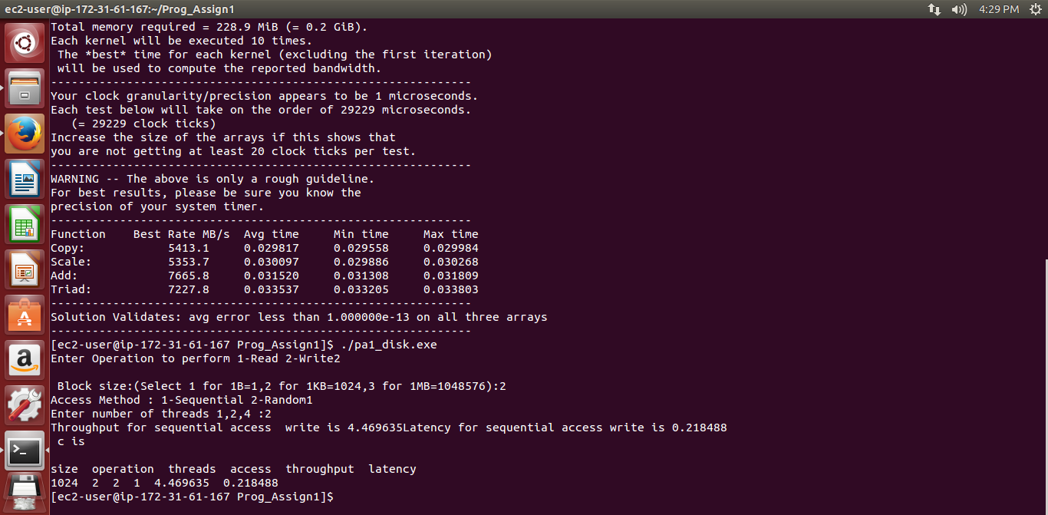

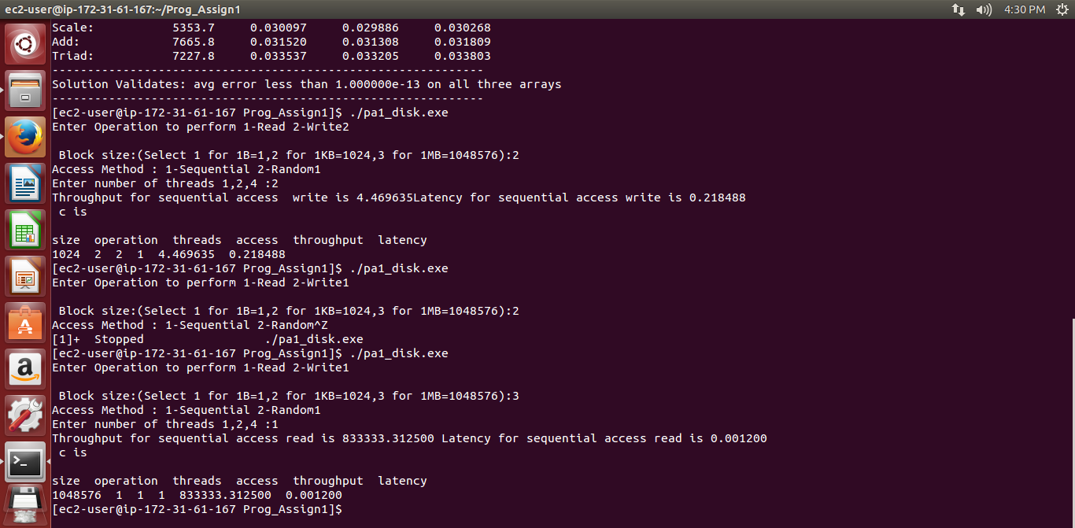

Memory Screenshot

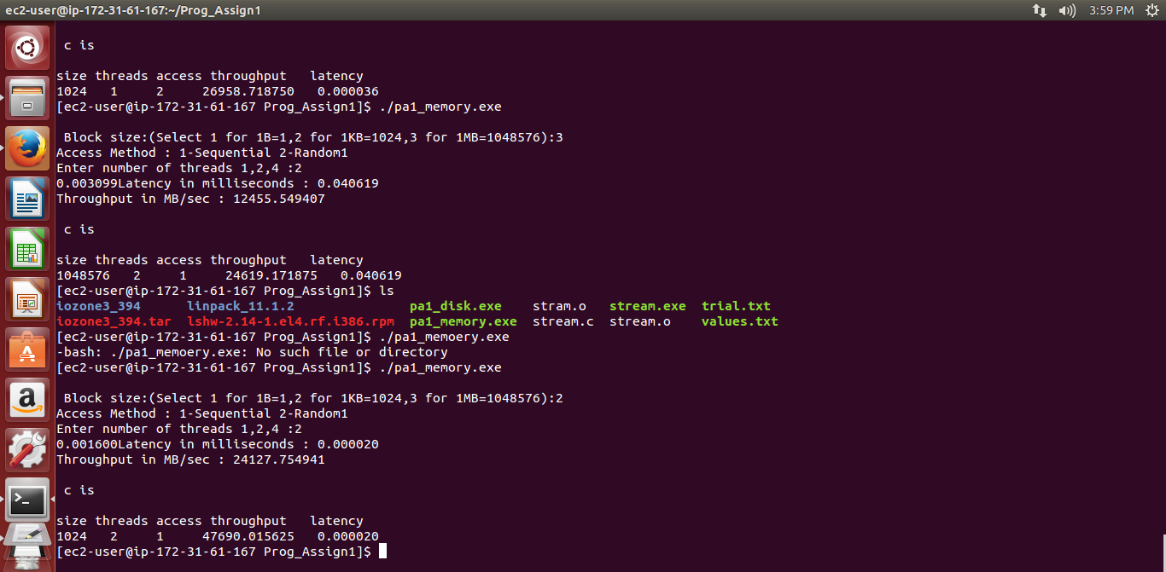

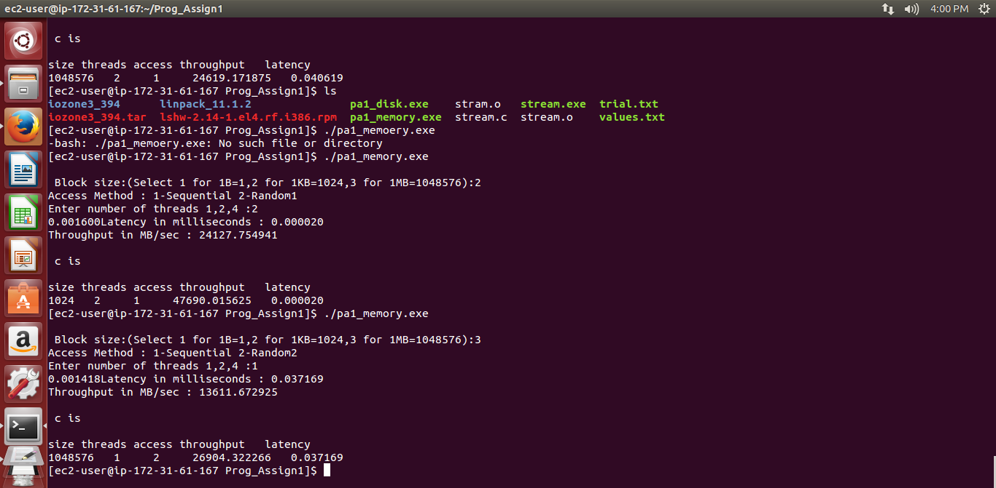

Cpu Screenshot

